**SQL_Reverse Engineering**

**Reverse-engineering** is the act of dismantling an object or process to see how it works. It is done primarily to analyze and gain knowledge about the way something works but often is used to duplicate or enhance the object.

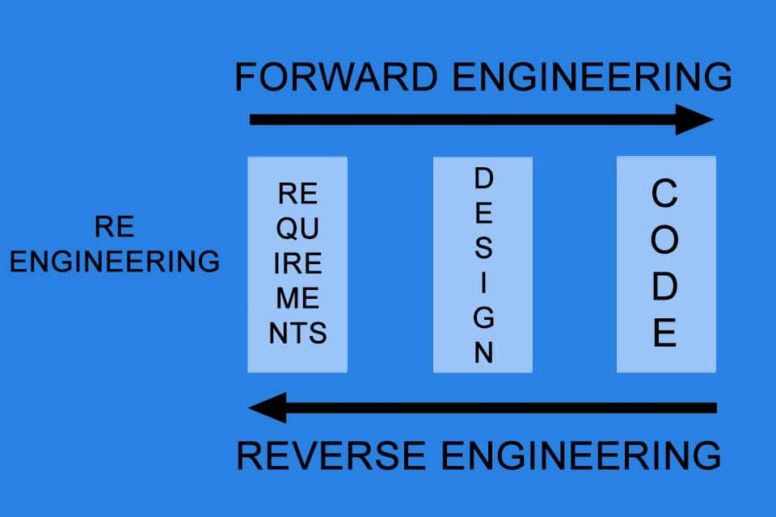

* **SQL Reverse Engineering:**

Database reverse engineering is the process that involves obtaining a database schema through its implementation, that is, through the definition of its objects.

**SQL Script**

**Model (ERD)**

1. **Let’s perform SQL reverse engineering by creating a SQL Script and converting it into an ERD model.**

|  |
| --- |
| Ward |
| Ward_No |
| Floor |
| Nurses |
| Beds |

Schema –

|  |
| --- |
| Patient |
| ID |
| Name |
| DOB |
| Address |
| Doctor_ID |
| visit_date |

|  |
| --- |
| Doctor |
| Doctor_ID |
| Doctor_name |
| Specialization |
| Ward_No |
| Salary |

Sql script: create database reverse;

use reverse;

create table ward(ward_no int primary key,floor int,nurses int,bed int);

create table doctor(doctor_id int primary key,doctor_name varchar(40),specilaisation varchar(40),ward_no int ,salary int,foreign key (ward_no) references ward (ward_no));

create table patient (id int primary key,name varchar(30),dob date ,address varchar(40),doctor_id int,visit_date date,foreign key (doctor_id) references doctor (doctor_id));

er model:

so we can say each doctor can handle multiple patients and each ward can have many doctors.so one to many relationship is shown in below er model.

